

Newsletter Autumn 2025!
Team Updates
It has been an exciting time here at Support & Connections. Our team is growing, in more ways than one, and we are excited to introduce you to a few new faces!


Meet our new Suport Worker, Jane who joined the team in August and has quickly become an integral part of the team.
Meet Lizzie, our Administrative Assistant, who joined our team in Septmeber and has been working hard on our IT needs!
Lizzie
Jane

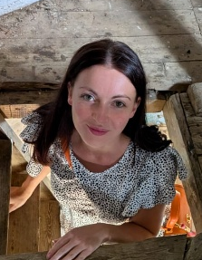

Meet Sophie, our newest Support Worker, who joined us this month. We are all exctited to get to know her more and tap into her skills!
Lastly, we are excited to introduce you to Nancy’s beautiful baby boy, Noah! Mum and baby are both doing well and we can’t wait to meet him.
Sophie
Noah

Oakham Farm Visit
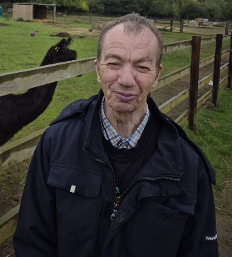
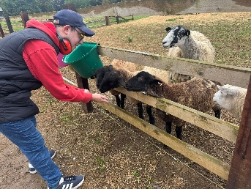
A group at our Oakham base visited the local farm park recently and had a blast! They really enjoyed meeting the animals, seeing the tractors and a lovely cup of tea, especailly as the had the farm to themselves!
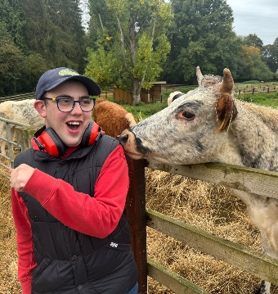
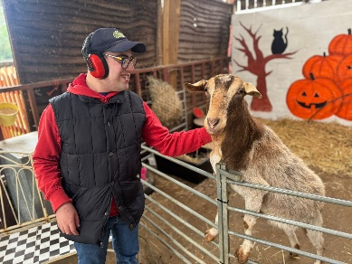

World Alzheimer’s Month
September was World Alzheimer’s Month, and we raised awareness and money in lots of different ways. We wore blue, made and sold blue jewellery and forget-me-not brooches, and had a special “down memory lane” music and movement session.
On October 11th, some of our amazing team participated in the sponsored Memory Walk at Wollaton Hall which was organised by the Alzheimer's Society. They walked 3K around the grounds with over 1000 other people.
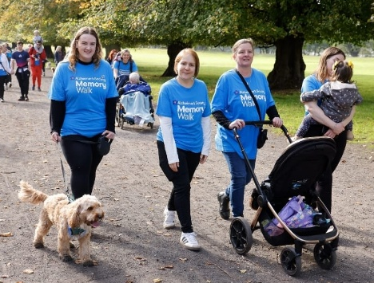
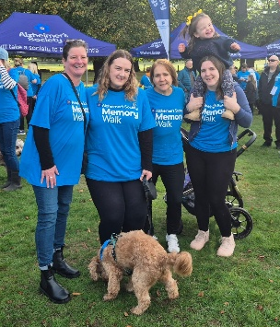
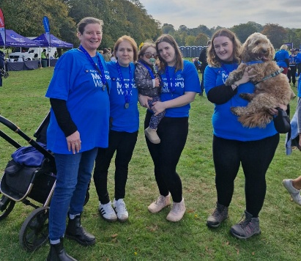

We are thrilled to announce that the grand total of money that was raised
for the Alzheimer’s Society this year is £192.03. A huge congratulations to
everyone involved and a special thank you to our Mental Health First Aider,
Ruth, for leading the fundraising efforts!

Dates for Your Diary
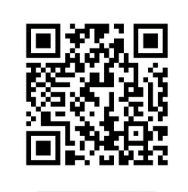
We will have a Christmas tree on display at
St Mary’s Church Christmas tree Festival on 28th November - 2nd December.

Christmas Closures:
Open: Monday 22nd and Tuesday 23rd December
Scan this QR Code to visit our website !
Closed: Wednesday 24th December – Thursday 1st January
Open: Friday 2nd January

As usual, we will be celebrating the festive
season with all our service users and staff – details to follow!

