

**Newsletter Spring 2025!**

**Mental Health Awareness Week 2025!**

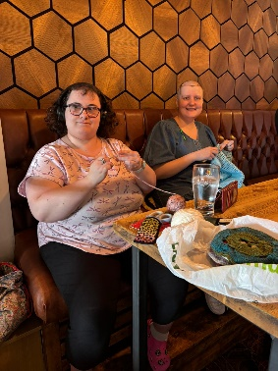We recently celebrated Mental Health Awareness Week. The theme was community, and we enjoyed lots of fun and relaxing activities together. We wore green ribbons, made blue tulip crafts, jewellery, and cookies, and had a lovely yoga session. We also shared cake and chats during tutor time, had a tasty meal at a local pub, and finished the week with a Feel-Good Friday pub trip. It was a great week full of friendship, creativity, and fun!

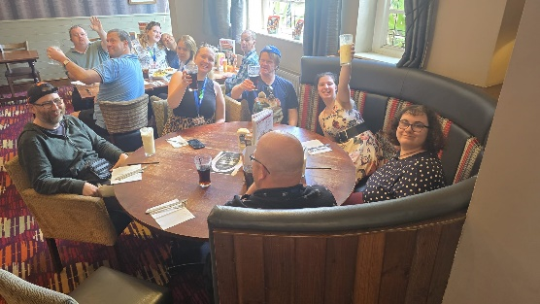

**1940’s Weekend Market Stall**

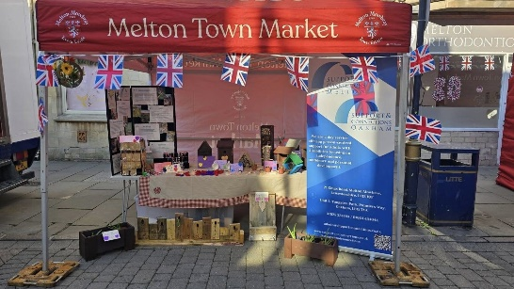We had a fantastic time at the 1940s weekend with our market stall! We sold lots of amazing handmade items from our Growing Community Enterprises, including woodwork, jewellery, plants, and crafts—all made by our very talented service users. It was a big success, and we were so pleased to have such wonderful support from the local community. All profits will be reinvested into our enterprises and services users given a profit share. Thank you to everyone who helped make the day so special!

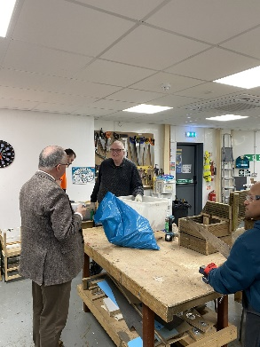**Visit from the Police & Crime Commissioner**

We had a special visit from the Police and Crime Commissioner of Leicester, Leicestershire & Rutland, Rupert Matthews. He came to see what we get up to at Support & Connections and to learn more about how we help people feel safe and supported. It was great to show him around and share the amazing work we do, he even ordered a planter!

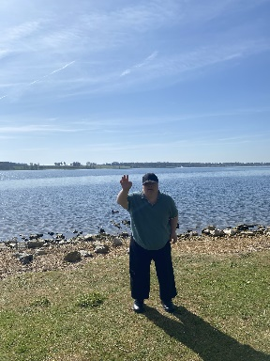

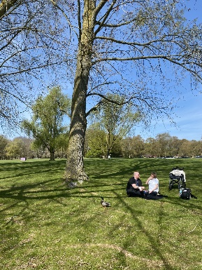

**Rutland Water Trip**

In April, we enjoyed a lovely trip to Rutland Water. We went for a peaceful walk and made the most of the spring sunshine. It was a great day to get out in nature, relax, and spend time together.

**LCC Partnership Awards**

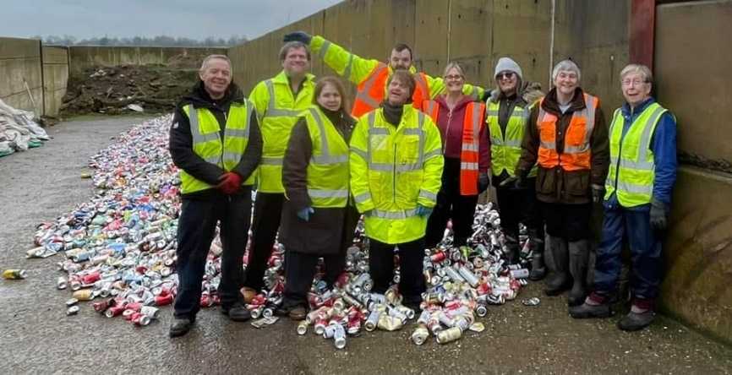We were invited to attend the LCC Partnership Awards. We are so proud of our service users who won the Community Champions award for their amazing contribution to the Air Ambulance charity through their dedicated can-crushing work. They truly deserved the recognition and had a fantastic time celebrating at the event. Over £14,000 has now been raised .Well done to all involved!



**Scan this QR Code to visit our website !**