

Newsletter Summer 2026!
Circus Trip

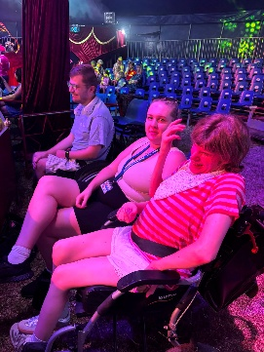
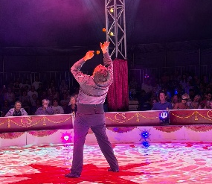
As you may know, in August we went to watch Cirquoise 2026 at Gates Garden Centre in Oakham. It was the biggest trip we’ve been on so far and we had a blast! We got there in time to secure ringsides seats, and the acts were all incredible. Everyone was mesmerised for the whole show. Afterwards we went to Lands End for lunch which was delicious. A fabulous day had by all!
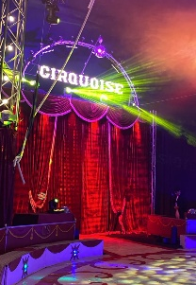
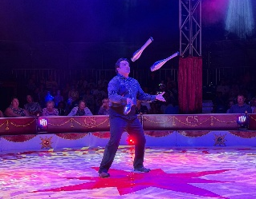

Staff Updates
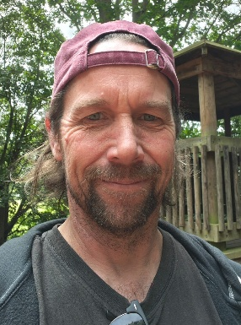
We are pleased to introduce Jonny, our newest Support Worker. Jonny brings with him an expertise in woodwork, as well as his guitar! We are looking forwards to exploring more music sessions with Jonny.
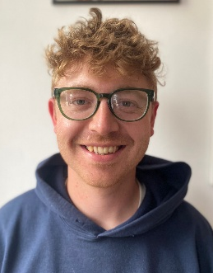

Sam joined us temporarily over the summer, thanks for all your help and good luck in your new role.

Some of you may already know Gina, who has recently joined us as a volunteer, offering up her time to help out during various sessions.

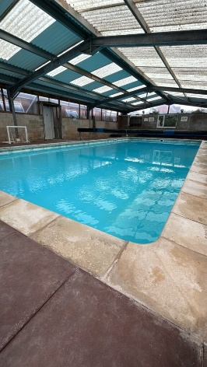
Swimming Sessions
We are lucky enough to have discovered a private swimming pool that is located on a farm in Hungarton. A small group attend the pool about once a month on a Friday, with different people in attendance each time. Everyone that goes has great fun with the floats and inflatables that are there!

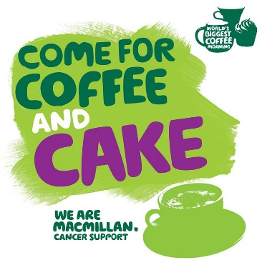
Macmillan Coffee Morning
On Tuesday 29th September we will be holding a Macmillan Coffee Morning in place of our usual Hideaway Takeaway. We will be serving cakes and hot drinks, with all proceeds going to Macmillan Cancer Support. Please join us from 10am – 12pm to raise as much as we can for such a good cause!

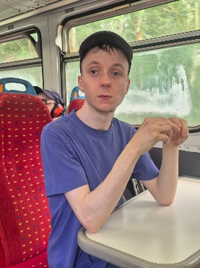
Great Central Railway
In July we visited the Great Central Railway for their Deisel-Car event. We had a fab time travelling on all the different trains and looking at the old stations!
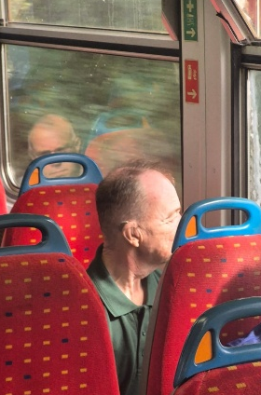
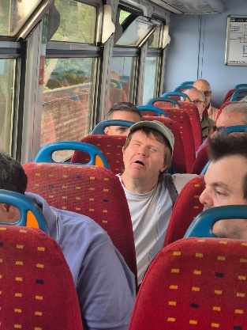
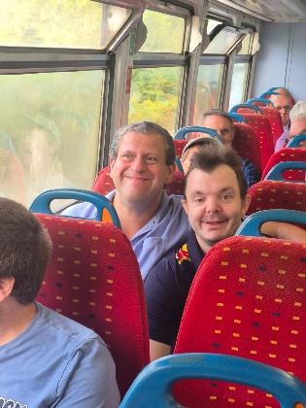



Scan this QR Code to visit our website!

