

Newsletter Spring 2026!

Mental Health Awareness Week 2026!
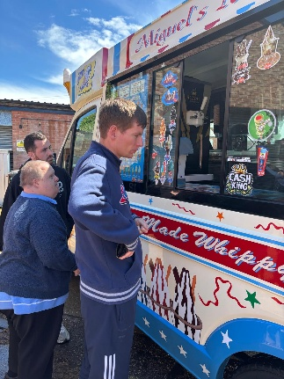
We recently celebrated Mental Health Awareness Week. The theme was community, and we enjoyed lots of fun and relaxing activities together. We wore green ribbons, had a visit from the ice cream van and had a lovely time creating different things together!

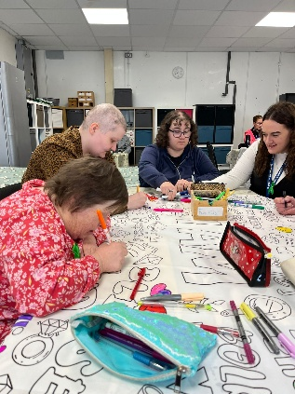
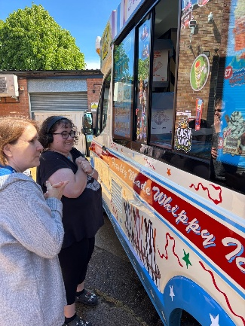
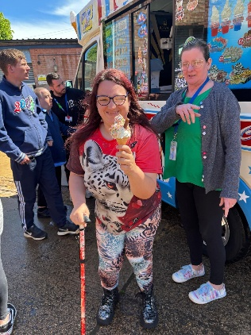

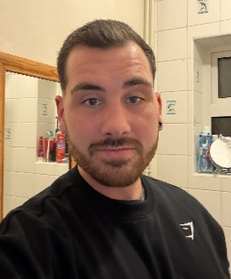
Support & Connections Staff Updates
We would like to introduce Dan, who recently joined our team as a Support Worker. Some of you may already know Dan from his previous workplace, and we’re sure you’re as excited as we are that he has chosen to join us! We are looking forward to putting his woodworking skills to the test.

We are also saying a fond farewell to Bex, who has moved on to her next adventure. We wish her all the happiness in her new role, and all the best for the future.

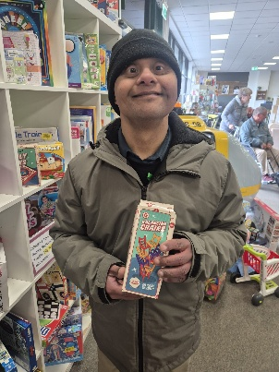
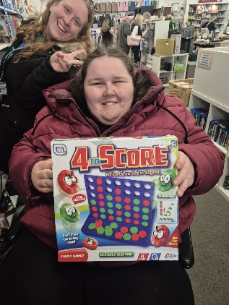
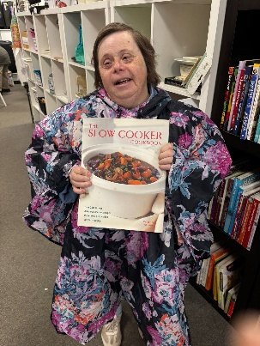

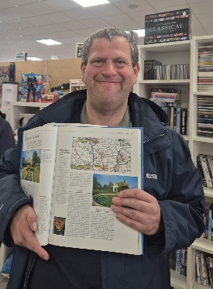
Our GoLearn! Sessions
Our GoLearn! Sessions with Jo have come to and end for this academic year, and what better way to mark it than with a trip to the charity shop! This time we went armed with bags of donations and everyone felt a true sense of fulfilment by giving back. We also went on a scavenger hunt where we each had something unique to try and find!

Morris Dancing with Way of the Wyrd
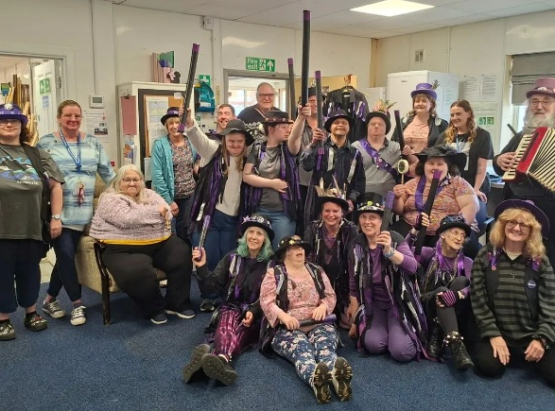
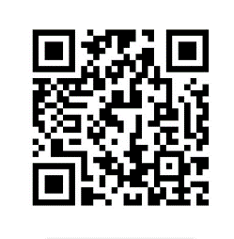
We had a fantastic time when our new friends – Way of the Wyrd – came in and taught us some Morris Dancing! The energy was incredible and everybody enjoyed joining in with the costumes, face paints, music and dancing. It was so much fun!
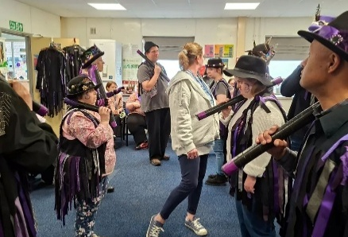
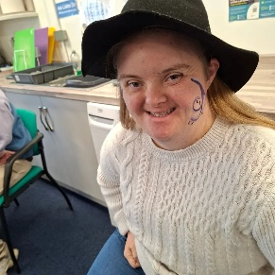
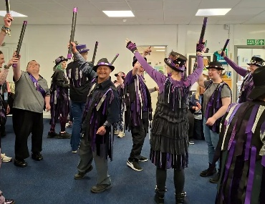
Scan this QR Code to visit our website!

